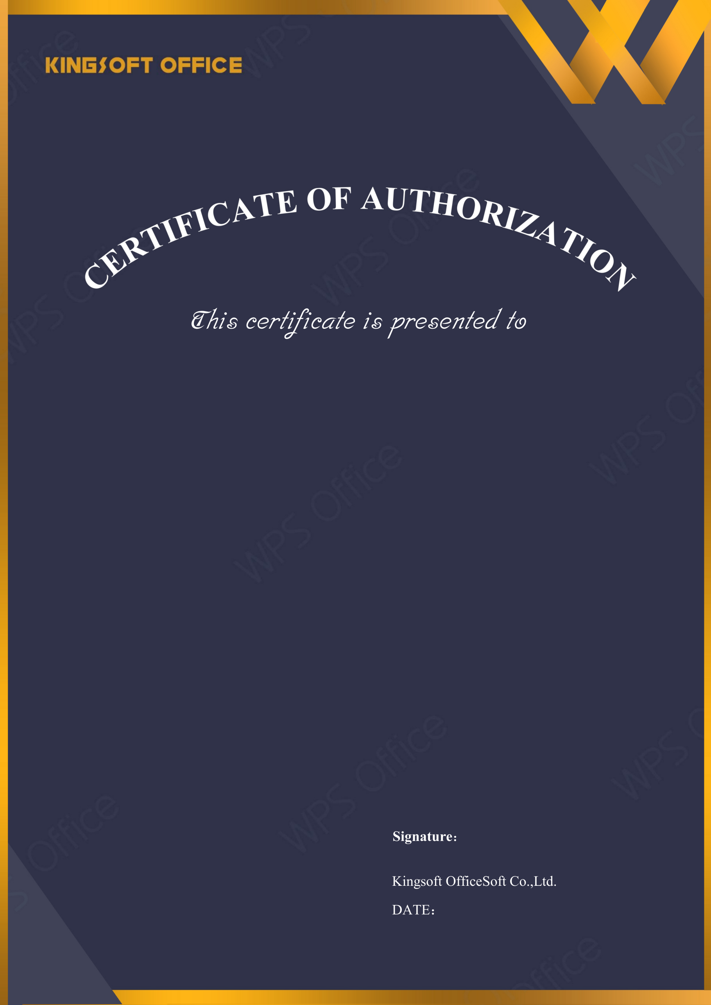
2026-04-21
ICTG. SG

Licensed Software: | WPS Office for Business
License Type: | Quantity License
Licensed Quantity: | 20
License Start Date: | 2026-04-21
License Expire Date: | 2027-04-21
Upgrade Deadline: | 2027-04-21
License Number: | PPG3X-A2BSY-67471-4FLRF-FYXZF



